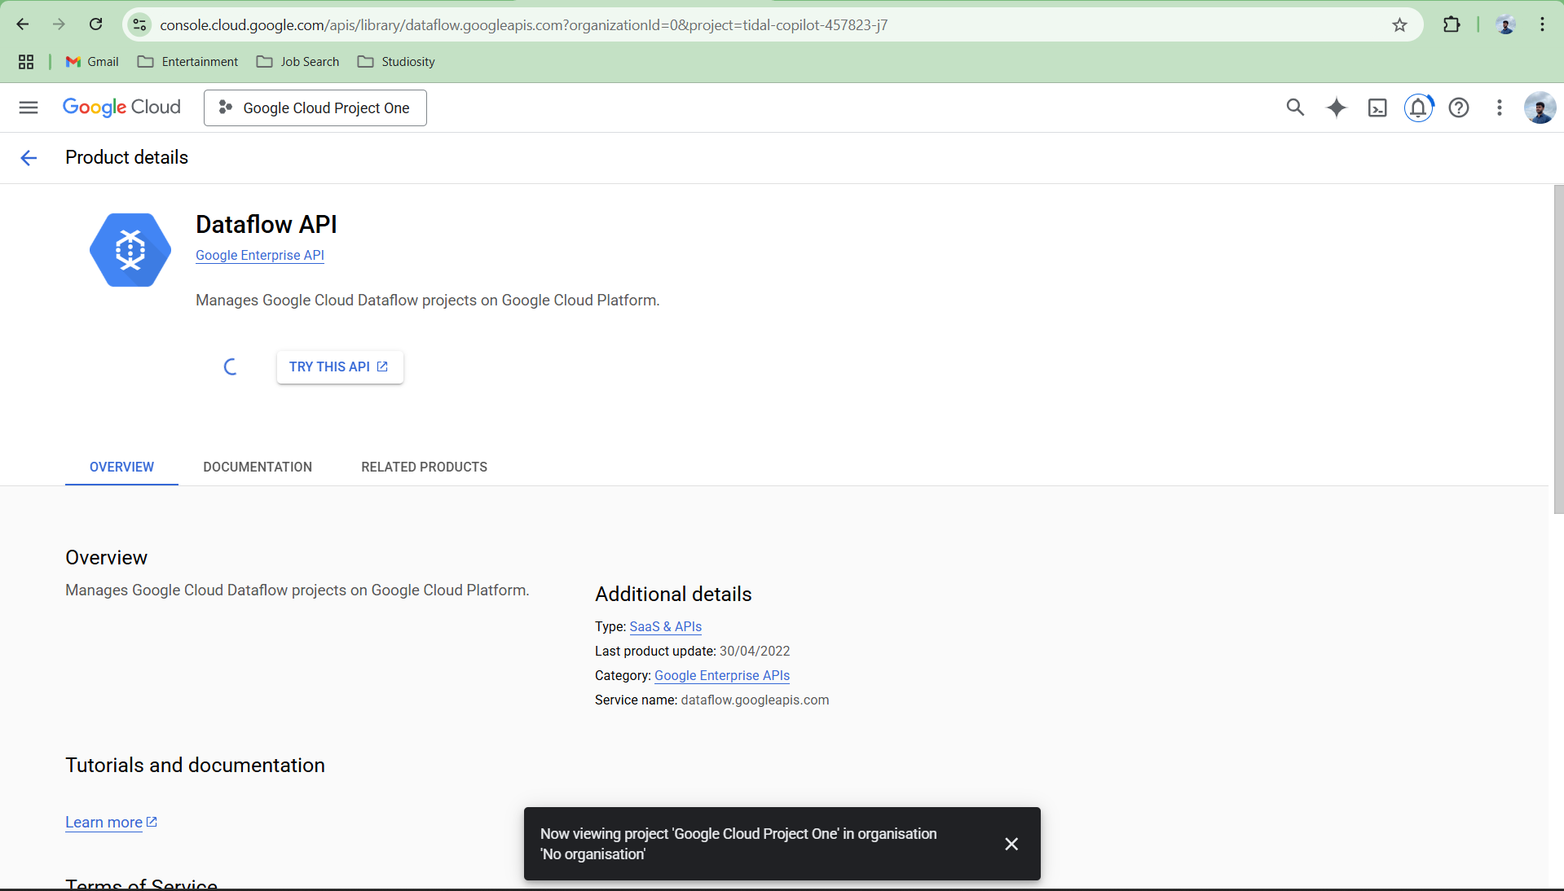

Create a google cloud project and enable dataflow api, cloud storage api

Create a bucket for the project created

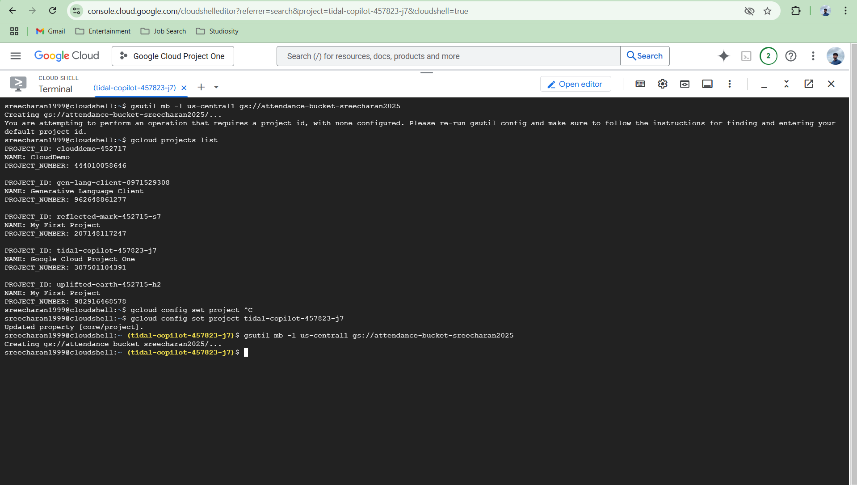

Create attendance.py and notes.py and paste the given code and input in these files.

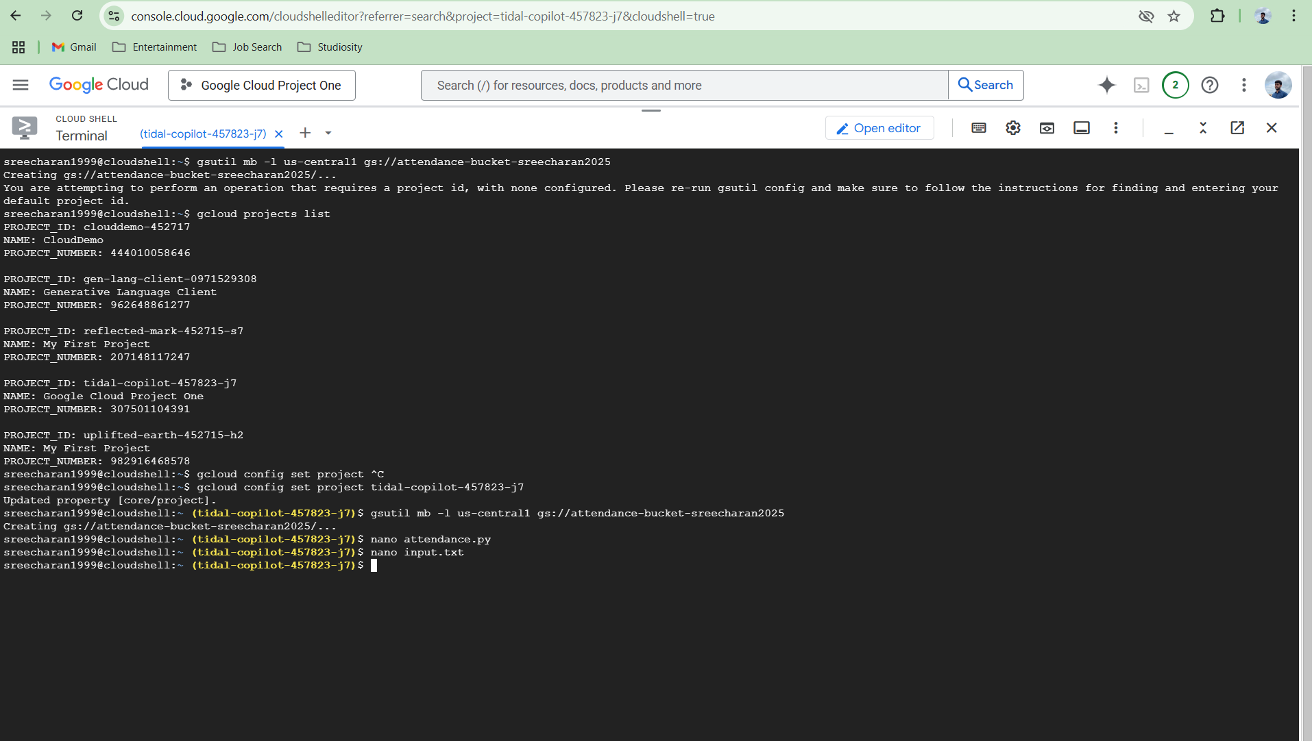

Upload both files to bucket

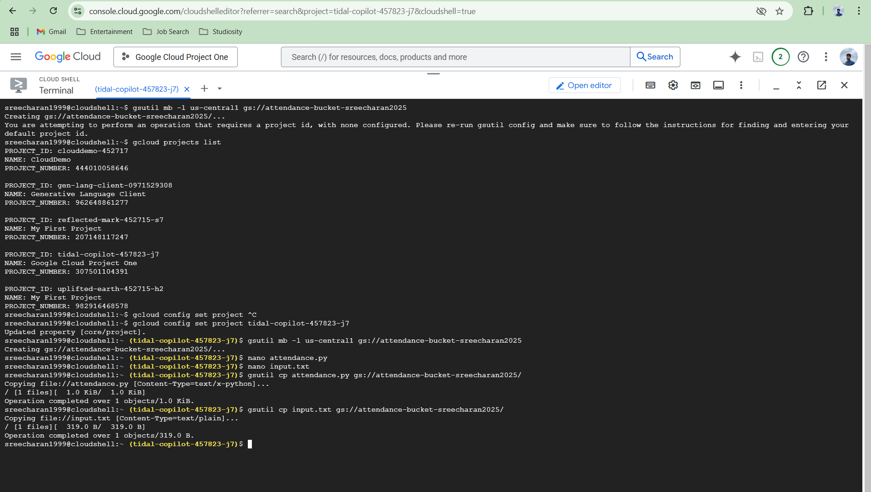

Install apache beam and then run the command

Go to jobs and see the graph

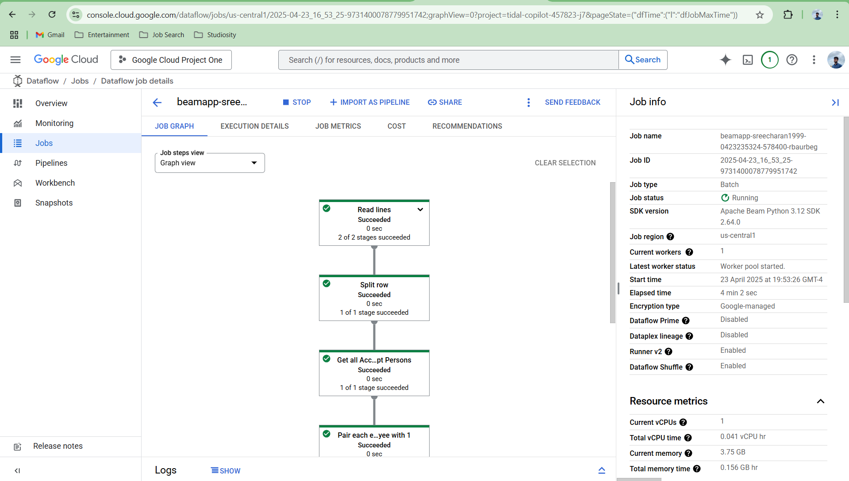

See the result in the bucket

